39.12: (a) 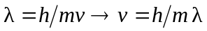
Energy conservation: 